Collaborating Within and Across Teams to Manage Data and Models

Lab 01: Extracting Useful Information from Resumes Using Document AI

Service Introduction
Google Cloud Document AI is a suite of tools designed to automate the extraction of structured information from unstructured documents. It leverages advanced machine learning models to analyze, classify, and extract data from a variety of document types such as invoices, receipts, contracts, and more. Here are some key features and benefits:
- Document Understanding: Document AI can parse and understand the content of documents, converting them into structured data that can be easily analyzed and used in other applications.
- Automated Data Extraction: It automates the extraction of key information from documents, such as names, dates, addresses, and amounts. This reduces the need for manual data entry and speeds up processing times.
- Multi-format Support: Document AI supports various document formats, including PDFs, images, and scanned documents. This flexibility allows organizations to process a wide range of document types without requiring manual conversion.
- Custom Models: Users can train custom models to handle specific document types and extraction needs, improving accuracy and relevance for specialized use cases.
- Scalability: Built on Google Cloud's infrastructure, Document AI can scale to process large volumes of documents efficiently, making it suitable for enterprises with high document processing needs.
- Integration: Document AI integrates seamlessly with other Google Cloud services, such as Cloud Storage, BigQuery, and Google Workspace, enabling streamlined workflows and data management.

Problem
As a member of the Human Resources department at XYZ Corporation, you are tasked with processing a large volume of resumes received from job applicants. Manually extracting textual information from each resume is time-consuming and prone to errors. This includes extracting details such as the candidate's name, contact information, work experience, education, skills, and other relevant data points. The current manual process hampers the efficiency of our recruitment workflow and delays the hiring process. The objective is to automate the extraction of textual information from resumes using Google Cloud Document AI.

Solution
1. From the search bar at the top, search for the “Cloud Document AI API”. API needs to be enabled before we start our work.
2. Click on “ENABLE”.
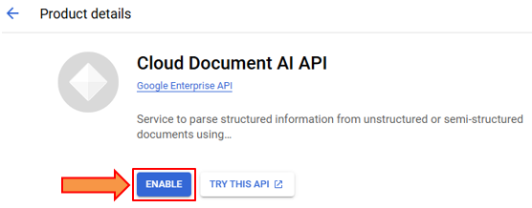
2. There are two options:
- Either choose from already existing processors.
- Or create a custom one.
In this problem we will use an already existing one. However, it is important to know how to use a custom option.
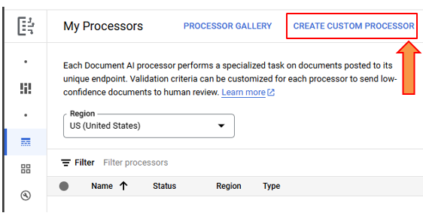
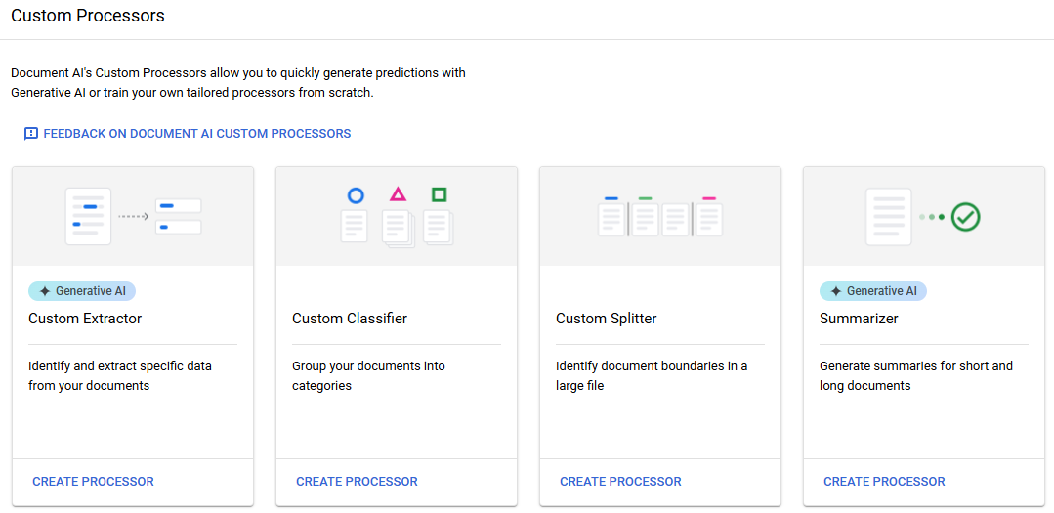
3. From the processor gallery, search for Document OCR.
4. Click on “CREATE PROCESSOR’.
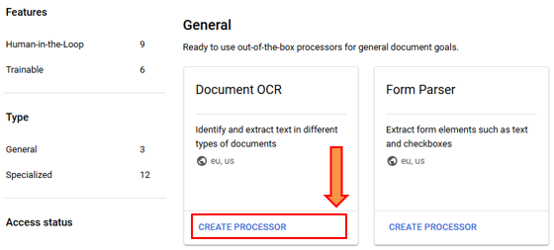
5. When the processor is ready, click on “UPLOAD TEST DOCUMENT”. Select the document (resume) from file explorer.
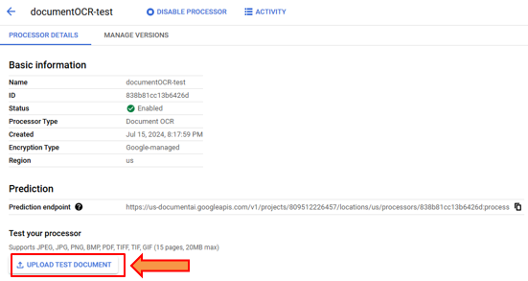
6. This is the output. On the left, we have the textual information which can be downloaded in JSON format. On the right we have the resume. Upon hovering the cursor it highlights the extracted information.
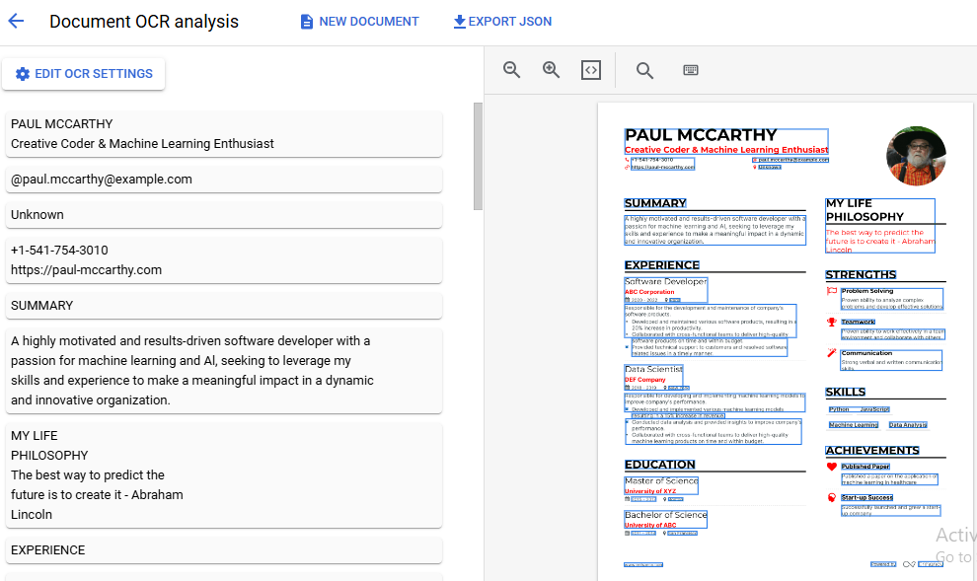
7. We can create a pub/sub topic or a trigger that executes the above process automatically whenever a resume is added to the storage bucket.

